Experimental study of the static behaviour
of the PEM fuel cell
Nedjem-Eddine.BENCHOUIA ^{#1}, Bouziane Mahmah^{*2}
# Mechanical Department, Faculty of science and Technology, Mohamed Cherif Messaadia University,
P.O.Box.1553 Annaba Road, Souk ahras, 41000, Algeria.
¹n.benchouia@univ-soukahras.dz
* b Bioenergy and Environment Division, Research Center of Renewable Energies Development.
P.O.Box. 62 Observer Road, Bouzaréah, Algiers, 16000, Algeria.
² mah2bouziane@gmail.com

Abstract— This work proposes and justifies an easy electric model of a power generation system based on a PEM fuel cell, the H-Tec PEM Power Module of 1.2W. This model has been developed by means of experimental data obtained in our laboratory.

Keywords— Fuel cell; PEMFC; Static; Modeling; Experimental.

- Introduction
A fuel cell system is one of the environmentally friendly alternative power systems to conventional fossil power systems. PEM fuel cell is considered to be a promising power source, especially for transportation and stationary cogeneration applications due to its high efficiency, low-temperature operation, high power density, fast startup, and system robustness [1]. PEM fuel cells are suitable for portable, mobile and residential applications [2].

In this study; firstly, general information about the fuel cells basic operation is presented. Then the static mathematical models of the PEM fuel cell are investigated and presented. On the other hand, the characteristic of 1.2 W PEM fuel cell is obtained by experiments.
- Fuel Cell Basic Operation

The fundamental structure of a PEMFC fuel cell can be described as two electrodes (anode and cathode) separated by a solid membrane acting as an electrolyte (Fig 1). Hydrogen fuel flows through a network of channels to the anode, where it dissociates into protons that, in turn, flow through the membrane to the cathode and electrons that are collected as electrical current by an external circuit linking the 2 electrodes. The oxidant (air in this study) flows through a similar network of channels to the cathode where oxygen combines with the electrons in the external circuit and the protons flowing through the membrane, thus producing water.

A typical type of fuel cell is the PEMFC. The electro-chemical reactions at the anode and cathode in a PEMFC are shown below:

Anode reaction: (1)
Cathode reaction: (2)
Total cell reaction: (3)

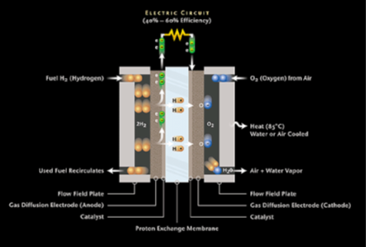

Fig.1 The operating principle of PEMFC.

- PEMFC static behavior model

This section presents an electrochemical model, which can be used to the static behavior of PEMFC stack .This mathematical model uses a group of parameters, whose definition is essential for the best simulation results. It is wise at this point to define the output voltage of a single cell, which can be defined as follow [3]:

(4)

And, for N cells connected in series, forming a stack, the voltage, Vstack, can be calculated by:

