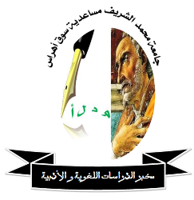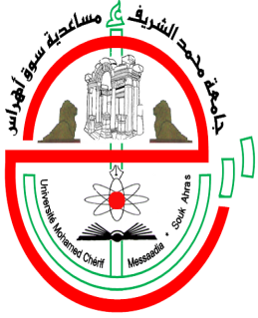
People's Democratic Republic of Algeria
Ministry of Higher Education and Scientific Research
Mohamed -Cherif Messaadia- Souk Ahras University
The laboratory of Linguistic and Literary Studies Organizes
In coordination with the Faculty of Arts and Languages
The First National Conference
“Orientalists and Contemporary Arab Literature: Reception” and Influence”
March 06-07/ 2017

Conference Problematic
There is much talk about the achievements of the orientalists, whether poetry or prose, creativity or thought, what they have reached from achievement, translation and publication. Having studied and discussed many traditional texts like “the Thousand and a night” (kalila wa Dimna….
In front of the magnitude of these achievements and their ramifications, one wonders about the luck of contemporary Arabic literature from orientalist interest, and their familiarizing and care with it, hence came the idea of this conference, which is trying to answer these problems:
- How did Orientalists receive contemporary Arab literature? And what are their impacts upon it?
- What are their interests? and how manifested this interest?
- What are the most attractive literary races of orientalists?
- What are the literary texts that have been translated and studied? And how could be received? And why?
- What is the impact of orientalist thought on Arab literature — generally thought- contemporary world?
Axes:
- Orientalists and contemporary Arabic poetry
- Orientalists and Arabic novel and story
- Orientalists and theater
- The teaching of modern Arabic literature and contemporary in Global Universities
- Orientalists and Arab literature written in another language (Francophone, Anglophone, ...)
- Orientalist fantasy in thought and contemporary Arab literature (Taha Hussein, Chabi, Naima, etc ...)
Honorary President of the Conference: Pr. Dr Zoubir Bouzebda (University Rector)
Chairperson of the Organizing Committee of the Conference: Dr. Madiha Atik.
Scientific Committee:
- Taher Rouainia Pr University of Annaba ( President of the Scientific Committee)
- Salima Loukam Pr University of Souk Ahras
- Abed el Ouhab Shaalan Pr University of Souk Ahras
- Bahae Bin Naour MCA University of Souk Ahras
- Djmoui Saadi MCB University of Souk Ahras
- Samia Alioui MCA University of Souk Ahras

Organizing Committee:
Salima Mahfoudi/ Yasin Seraiia/ Imad Boukhari/ Farouk Belahcen/ Nacira Messabhia/ Meriem Kater
Important Dates:
- Deadline for receipt of abstracts (Curriculum Vita) is22/02/2017
- Submission of full paper22/03/2017
- Notification of acceptance and sending Invitation 26/03/2017
- Conference Venue: The9th April2017, the ancient university.

Final Paper Submission Process:
- We welcome original papers, on any topic relevant to the mission of ““ Orientalists and Contemporary Arab Literature: Reception and Influence”
- The full paper should not exceed 20 paper, and not less than 12 paper
- It should be written in Traditional Arabic 16 font size, the margins in the last article 14 font size
- Keywords: do not exceed 8 keywords
- Conference language: Arabic, French and English
- That might be individual
- Abstract may be sent to the following e-mail address: conf.orient@univ-soukahras.dz

