وزارة التعليم العالي والبحث العلمي

Ministry of Higher Education and Scientific Research
جامعـة محمد الشريف مساعدية  سوق أهراس | 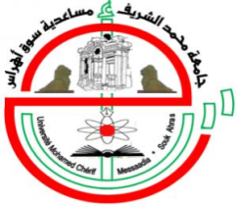 | Mohamed Cherif Messadia University Souk Ahras

Faculty of Science and Technology

Department of ………………

Academic Year: 2024/2025

MASTER THESIS
Presented in fulfillment of the requirements for the Master’s Degree
Title

Field of Study

Title of the Field
Specialization

Title of the Specialization

By
Student 1 Full Name and Student 2 Full Name
 | THESIS SUPERVISOR : Full Name |  | Degree | U.SOUK-AHRAS
 | THESIS CO-SUPERVISOR : Full Name |  | Degree | U.SOUK-AHRAS

Behind the jury

PRESIDENT : Full Name |  | Degree | U.SOUK-AHRAS
EXAMINER 1: Full Name |  | Degree | U.SOUK-AHRAS
EXAMINER 2 : Full Name |  | Degree | U.SOUK-AHRAS
No. ……./2025

