Chapter 1: Introduction to Hydrology
I.1.Introduction
Hydrology is the earth science that focuses on the water cycle, encompassing the exchanges between the atmosphere, the earth's surface, and its subsurface. The term "hydrosphere" refers to the part of the planet where water is found. Hydrological cycles are thus present within the hydrosphere. As part of the exchanges between the atmosphere and the earth's surface, hydrology concerns itself with precipitation (rain and snow), the transpiration of plants, and the direct evaporation from the superficial terrestrial layer.
- Surface hydrology studies runoff, erosion phenomena, river flows, and floods.
- Groundwater hydrology or hydrogeology deals with subsurface water resources, including their extraction, protection, and renewal.
- Urban hydrology constitutes a "sub-cycle" of water linked to human activity: the production and distribution of drinking water, and the collection and treatment of wastewater and stormwater.

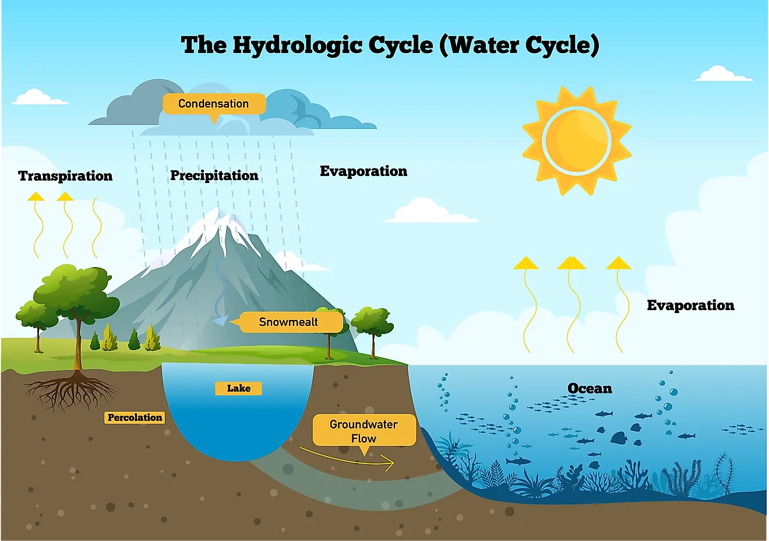
Figure 1.1 : water cycle ( wikipedia 2023)

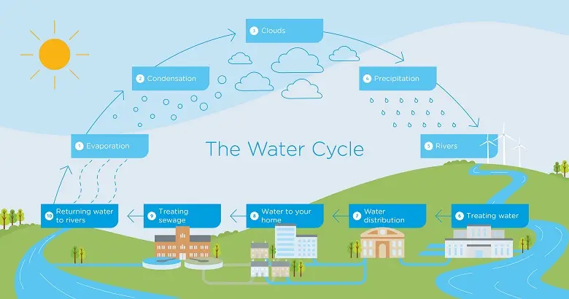

Although these domains are intrinsically linked to each other, it is useful to distinguish these different aspects of hydrology because the hydrological engineer is capable of planning, studying, and managing projects aimed at controlling the use of water:

- Projects for the distribution of potable water, industrial water, irrigation, etc.
- Flood protection projects
- Dam management
- Irrigation or drainage projects

I.2.The Water Cycle and the Hydrological Balance
1. Where does the water in springs and rivers come from?
2. Where does rainwater come from?
3. Why doesn't the sea overflow?
The answers to these questions depend on scales of time and space.
At a planetary or continental scale, water evaporates from the oceans to form clouds. These clouds move towards the continents and partially transform into rain. This precipitation feeds rivers and aquifers, with a notable volume returning to its starting point, the oceans, thereby completing what is known as the "hydrological cycle." This cycle is disrupted by human activities (dams, irrigation, pollution).
Under the effect of solar radiation, water evaporates (E) from the soil, oceans, and other water surfaces, entering the atmosphere. The rising of a humid air mass allows the general cooling necessary to bring it to saturation and cause the condensation of water vapor into droplets that form clouds, in the presence of condensation nuclei. Then, the water vapor, transported and temporarily stored in the clouds, is returned via precipitation (P) to the oceans and continents.
Part of the falling rain may be intercepted by vegetation and then partially returned to the atmosphere as vapor. The rain that is not intercepted reaches the ground. Depending on the given conditions, it may then evaporate directly from the soil, flow on the surface to rivers (surface runoff, R), or infiltrate into the soil. There may also be temporary storage of the infiltrated water (I) as soil moisture, which plants can use. Percolation to deeper zones can contribute to the renewal of groundwater reserves. Flow from these reserves can surface at springs or in rivers. Thus, evaporation from the soil, rivers, and transpiration from plants complete the cycle.
This cycle involves several key processes:
- Evaporation: Water from oceans, rivers, and lakes evaporates into the atmosphere due to the heat from the sun.
- Transpiration: Plants release water vapor into the atmosphere from their leaves.
- Condensation: Water vapor in the atmosphere cools and condenses to form clouds.
- Precipitation: Water falls from the clouds to the Earth's surface as rain, snow, sleet, or hail.
- Infiltration: Some of the water that precipitates on land infiltrates into the soil and replenishes groundwater.
- Runoff: Water that does not infiltrate the soil flows over the surface and collects in rivers, lakes, and oceans.
The hydrological balance, or water balance, is a way to quantify the inflows, outflows, and storage of water in a given system. It is crucial for understanding and managing water resources. The main components of the hydrological balance are:
- Inputs: Precipitation and any additional water entering the system.
- Outputs: Evaporation, transpiration, and water leaving the system (such as river discharge).
- Storage Changes: Variations in the volume of water stored in different components of the hydrosphere, such as groundwater, soil moisture, and surface water bodies.
By analyzing the hydrological balance, engineers and scientists can assess water availability, predict droughts or floods, and plan sustainable water management strategies.
The hydrological balance can be expressed by the following equation:
P = E+R+I (1.1)
Where:
P = Total precipitation
E = Evaporation + Transpiration from plants
R = Surface runoff
I = Infiltration

The global water balance has been approximately established in Table 1.1 (Adapted from Gleick, 1993).

Table 1.1: Global Water Balance
Component | Volume (km³/year) | Percentage (%)
Precipitation (P) | 125
Evaporation (E) | 1.25
Surface runoff (R) | 65
Infiltration (I)

Chapter II: The Watershed

2.1. Definition
The watershed is the geographical unit on which the analysis of the hydrological cycle and its effects is based. The watershed is also known as the drainage basin of a wadi, at a given point along its course. is the area bounded by the contour within which precipitated water flows towards that point of the wadi (Sari Ahmed ; 2009).
The watershed has a collector function; it collects rain and converts it into flow at the outlet. This transformation depends on the climatic conditions and physical characteristics of the watershed.
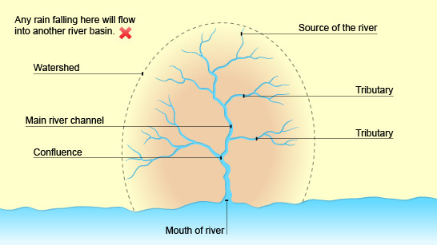
Figure 2.1 : Exemple de bassin versant
The outlet of a basin is the most downstream point of the hydrographic network through which all runoff drained by the basin passes.
The crest line of a watershed is the watershed divide. The line thus defined limits the topographic watersheds. However, the watercourse of a given watershed may be fed by precipitated water on a topographically adjacent basin. This is the case when there is an impermeable horizon or complex subterranean flows, as in karst terrain. In fact, Fig. 2.2 shows that in the event of a heavy rainfall, runoff water could reach the adjacent basin, while infiltrated water would flow into the main basin. The watershed is then different from the watershed strictly delimited by the topography. It is referred to in this case as the real catchment area.

