Chapter 2 the water shed

- Definition:
A watershed (also called a drainage basin or catchment area) is the geographic area that drains water to a common point. A watershed is a land area that channels rainfall and snowmelt into creeks, streams, and rivers, eventually leading to a common outlet such as a larger river, lake, or ocean.
- Characteristics of a Watershed:
- Drainage Divide:
  - The high land or ridge that separates one watershed from another.
- Outflow Point:
  - The location where water exits the watershed, such as a river mouth or lake.
- Area:
  - Size can vary from a few square kilometers to thousands, depending on the watershed.
- Slope:
  - Influences how quickly water flows; steeper slopes lead to faster runoff.
- Soil Type:
  - Affects infiltration and runoff. Sandy soils absorb more water; clayey soils lead to more surface runoff.
- Land Use and Vegetation:
  - Forested areas reduce runoff and erosion; urban areas increase it due to impermeable surfaces.
- Hydrological Cycle:
  - Includes processes like precipitation, infiltration, surface runoff, and evapotranspiration.
- Human Impact:
  - Dams, agriculture, deforestation, and urbanization can alter natural flow and water quality.

Key Elements:
- Crest (divide): The highest boundary that separates two watersheds.
- Springs: Points where groundwater emerges and starts forming streams.
- Streams and rivers: These collect water from higher elevations and flow toward lower ones.
- Outlet: The point where all the water from the watershed exits (e.g., into a lake or sea).
- Hypsometric Curve
- The hypsometric curve describes how elevation is distributed within a watershed.

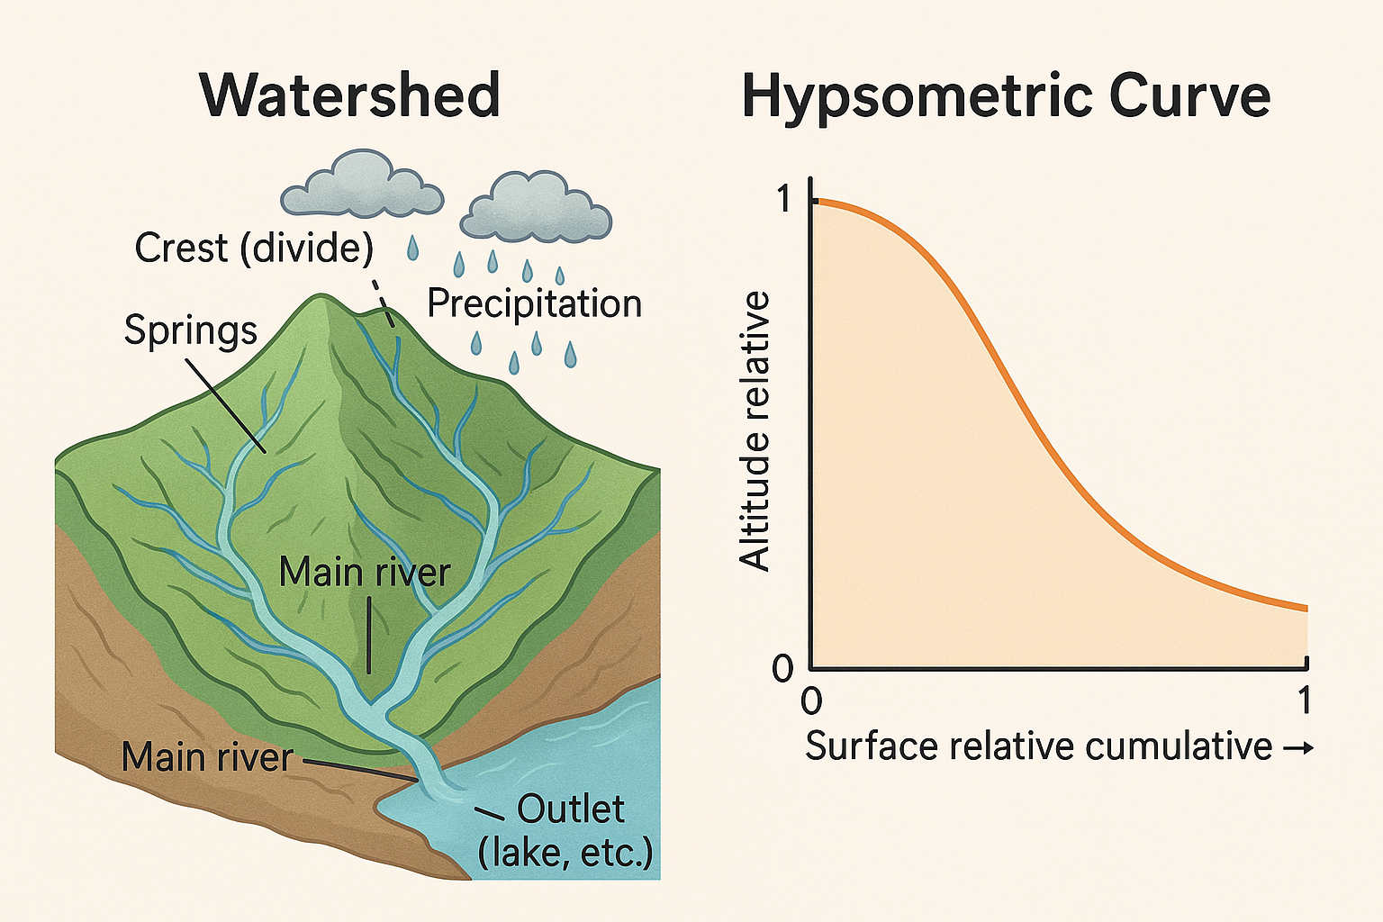
Crête (ligne de partage des eaux)
/\
/ \ (Pluie)
Montagnes / \ ☁️☁️☁️🌧🌧🌧
/ \ / \
/ \ / \
/ \ / \
/ \ / \
/ | \
Sources Ruisseaux Sources
\ | /
\ | /
\ | /
\ Rivière principale
\ | /
\ | /
\ | /
\ | /
\ | /
Exutoire (lac, mer, etc.)

1. Hypsometric Curve
- A hypsometric curve (or hypsographic curve) represents the distribution of elevation in a given area, such as a drainage basin.
- It plots relative elevation (height from 0 to 1) on the Y-axis against relative area (portion of total area) on the X-axis.
- Purpose: It shows how much land lies at different elevations. It’s useful for understanding erosional stages of a landscape (youthful, mature, old).
- A convex curve implies a youthful stage, while a concave curve suggests mature or old topography.

2. Equivalent Rectangle
- In geomorphological studies, the equivalent rectangle refers to a rectangle that has the same area as the shape being studied (like a watershed or drainage basin) but may have different dimensions.
- It’s used to simplify irregular shapes to a rectangle for easier calculation of morphometric indices like compactness or shape index.

3. Compactness Index (Compactness Coefficient)
- A measure of how compact or circular a shape is.
- Common formula:
C= P/2(πA)^{0.5}
Where:
  - P = Perimeter of the area
  - A = Area
- Interpretation: A compactness index close to 1 means the shape is close to a perfect circle (most compact); higher values suggest more elongation or irregularity.

4. Shape Index (Form Factor or Elongation Ratio)
- Quantifies the elongation of a shape.
- There are different versions, like:
  - Form Factor:
F_{f} = A/L²
• A = Area
• L= Maximum length

Hypsometric Curve Example
Example Basin Data:
Parameter Value
Area (A) 100 km²
Perimeter (P) 50 km
Max Length (L) 20 km
Elevation max 500 m
Elevation min 100 m
Hypsometric Data Relative elevation & area
Let’s say we have the following elevation distribution:
Relative Area (x) | Relative Elevation (y)
0.0 | 0.0
0.2 | 0.5
0.4 | 0.7
0.6 | 0.85
0.8 | 0.95
1.0 | 1.0
- You can plot this on a graph (x-axis = relative area, y-axis = relative elevation).
- This curve is convex upward, suggesting a youthful basin with less erosion.

Equivalent Rectangle
To create an equivalent rectangle:
- Area (A) = 100 km²
- Assume you choose a rectangle width = 10 km, then:
Length= 100/10 = 10 KM
So, your equivalent rectangle is 10 km x 10 km, maintaining the same area as the real basin.

3. Compactness Index
Use the formula:
C= 50/35.44= 1.41

Since 1 is a perfect circle, a value of 1.41 suggests this basin is moderately compact but not circular.

4. Shape Index / Form Factor / Elongation Ratio

a. Form Factor:
F_{f} = A/L² = 100/400= 0.25
- A low form factor (<0.5) means the basin is elongated.

b. Elongation Ratio:
Re​= 2(100/3.14)^{0.5} /20 = 0.56
- A value < 1 indicates elongation; closer to 1 means more circular.

Interpretation:
Metric | Value | Interpretation
Hypsometric Curve | Convex | Youthful basin
Compactness Index | 1.41 | Moderately compact (not circular)
Form Factor | 0.25 | Elongated shape
Elongation Ratio | 0.56 | Elongated basin

