Chapter III
Evaporation, Potential Evapotranspiration (PET): and Infiltration

Evaporation

Definition
Evaporation is the process by which water changes from liquid to vapor form, occurring on surfaces such as lakes, rivers, wet soil, or vegetation. It plays a key role in the water cycle.
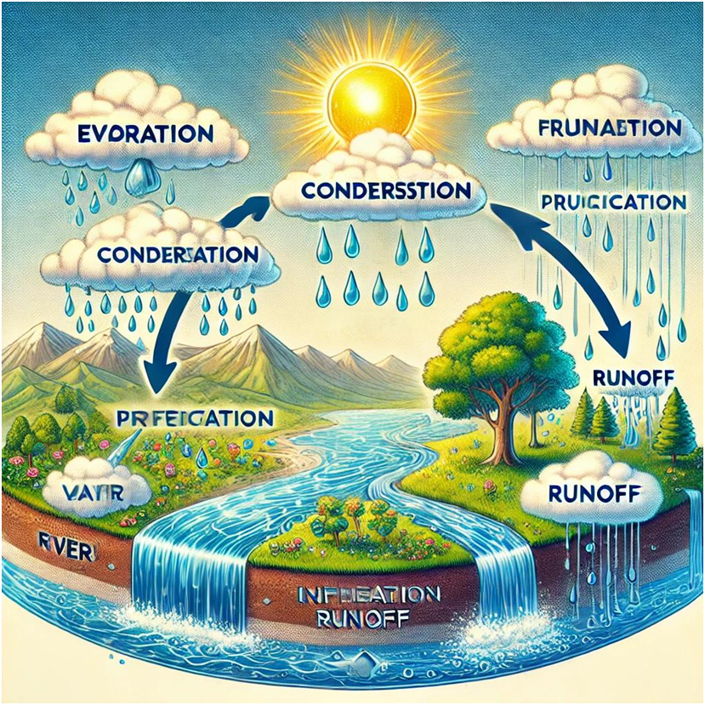
The image shows key stages of the water cycle, including evaporation (highlighted), infiltration, condensation, and transpiration

Factors Influencing Evaporation
- Temperature: Higher temperatures increase evaporation.
- Wind: Helps carry away water vapor, increasing evaporation.
- Relative Humidity: Lower humidity increases evaporation.
- Solar Radiation: Primary energy source driving evaporation.
- Water Surface Area: Larger areas allow more evaporation.

Evaporation Measurement
- Class A Evaporation Pan: Standard device for measuring water evaporation from a free surface.
- Empirical formulas (e.g., Turc, Penman, Thornthwaite) using weather data.

Evaporation Calculation (Penman Formula - Simplified)
E = (ΔRn + γf(u)(es - ea)) / (Δ + γ)
Where:
E = evaporation (mm/day)
Rn = net radiation (MJ/m²/day)
Δ = slope of the vapor pressure curve
γ = psychrometric constant
f(u) = wind function
(es - ea) = vapor pressure deficit

Potential Evapotranspiration (PET):

1. Definition
Potential Evapotranspiration (PET) is the amount of water that would evaporate and transpire from a reference surface if sufficient water is available. It represents the climatic demand for water, regardless of the actual moisture in the soil.

2. Characteristics
- PET depends on climatic factors such as temperature, solar radiation, humidity, and wind.
- It is independent of soil moisture (unlike Actual Evapotranspiration - AET).
- PET is used in hydrology, agriculture, irrigation planning, and water resources management.
- Higher PET indicates higher water demand for vegetation.

3. Evapotranspiration (ETP) Measurement
Evapotranspiration (ETP) is measured using different types of instruments. One of the most widely used is the Class A Evaporation Pan.

Class A Evaporation Pan
This is a standardized cylindrical pan made of galvanized steel or aluminum. It is filled with water and placed in open space to allow natural evaporation. The decrease in water level indicates evaporation and is used to estimate ETP.
Key Characteristics:
Diameter: 121 cm
Depth: 25 cm
Placement: On a leveled surface, in open area
Measurement: Daily water level decrease
ETP is calculated using: ETP = Kp × Epan
Where:
Epan: Measured evaporation from the pan (mm)
Kp: Pan coefficient depending on climate and environment.

4. Methods of Calculation

Turc Method (simple)
Formula:
PET = 0.013 × (T / (T + 15)) × (R + 50)
Where:
T: Mean monthly temperature (°C)
R: Global solar radiation (cal/cm²/month or MJ/m²/month)

Thornthwaite Method
Formula:
PET_m = 16 × (10 × T_m / I)^a
Where:
T_m: Mean monthly temperature (°C)
I: Annual heat index = sum of (T_m / 5)^1.514
a: Empirical coefficient depending on I:
a = 6.75×10⁻⁷×I³ - 7.71×10⁻⁵×I² + 1.79×10⁻²×I + 0.49

FAO-56 Penman-Monteith Method
Formula:
PET = [0.408 × Δ × (Rn − G) + γ × (900 / (T + 273)) × u2 × (es − ea)] / [Δ + γ × (1 + 0.34 × u2)]
Where:
Rn: Net radiation (MJ/m²/day)
G: Soil heat flux (≈ 0 for daily time steps)
T: Mean daily air temperature (°C)
u2: Wind speed at 2 m height (m/s)
es − ea: Saturation vapor pressure deficit (kPa)
Δ: Slope of the vapor pressure curve (kPa/°C)
γ: Psychrometric constant (kPa/°C)

Example Using Turc Method
Given:
T = 25°C
R = 180 cal/cm²/month
PET = 0.013 × (25 / (25 + 15)) × (180 + 50) ≈ 1.87 mm/day

Infiltration

Definition
Infiltration is the process through which water enters the soil from the surface. It replenishes groundwater and reduces surface runoff.

Factors Influencing Infiltration
- - Soil Texture: Sandy soils infiltrate more than clay soils.
- - Soil Structure and Porosity: More pores allow better infiltration.
- - Soil Moisture: Saturated soils have reduced infiltration.
- - Vegetation: Roots improve soil porosity and infiltration.
- - Slope: Steep slopes reduce infiltration and increase runoff.

Infiltration Measurement
- Single/Double Ring Infiltrometer: Measures how fast water enters the soil.
- Horton’s Method: Observes infiltration rate changes over time.

Infiltration Calculation (Horton’s Equation)
f(t) = fc + (f0 - fc)e^(-kt)
Where:
f(t) = infiltration rate at time t
f0 = initial infiltration rate
fc = constant (final) infiltration rate
k = decay constant
t = time

Examples and Exercises

Example 1: Evaporation from Pan
A Class A evaporation pan records 6 mm of water loss in one day. If the pan coefficient is 0.7, calculate the actual evaporation.
Data: Pan evaporation = 6 mm/day, Pan coefficient (Kp) = 0.7
Calculation: E = Kp × Pan evaporation = 0.7 × 6 = 4.2 mm/day

Example 2: Horton's Infiltration Calculation
Data: f0 = 10 mm/h, fc = 3 mm/h, k = 0.6, t = 2 h
Calculation:
f(t) = 3 + (10 - 3) * e^(-0.6 * 2) = 3 + 7 * e^(-1.2)
e^(-1.2) ≈ 0.301
f(t) ≈ 3 + 2.11 = 5.11 mm/h

Exercise
Data: Pan evaporation = 8 mm/day, Kp = 0.75
1. Calculate real evaporation.
2. How much water evaporates over 5 days?
Solution:
1. E = 0.75 × 8 = 6 mm/day
2. Total = 6 × 5 = 30 mm

