** Serie of exercices on mesomeric forms**

**Exercise 1**

Indicate the structures in which covalent bonds are correctly polarized.

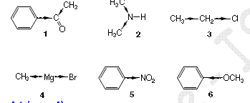

**Exercise 2**

For each of the following molecules, indicate the direction of the inductive (+I, -I) and possibly mesomeric (+M, -M) effect mesomeric effect (+M, -M) induced by the atoms or groups of atoms underlined**.**

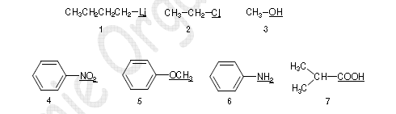

**Exercise 3**

Write down the mesomeric formulae of the following structures

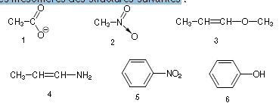

**Exercise 4**

Write down the mesomeric formulae of the following structures

