Wagner–Meerwein Rearrangement

A Wagner–Meerwein rearrangement is a class of carbon to a neighboring carbon. carbocation 1,2-rearrangement reactions in which a hydrogen, alkyl or aryl group migrates from one They can be described as cationic [1,2]-sigmatropic rearrangements, proceeding suprafacially and with stereochemical retention. As such, a Wagner–Meerwein shift is a thermally allowed pericyclic process with the Woodward-Hoffmann symbol [ω0s + σ2s]. They are usually facile, and in many cases, they can take place at temperatures as low as –120 °C. The reaction is named after the Russian chemist Yegor Yegorovich Vagner; he had German origin and published in German journals as Georg Wagner; and Hans Meerwein. Several reviews have been published. The rearrangement was first discovered in bicyclic terpenes for example the conversion of isoborneol to camphene:

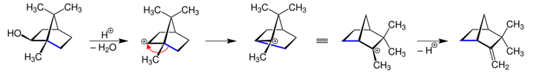

What is Beckmann Rearrangement?
The Beckmann Rearrangement is a reaction of the oximes that can bring about either nitriles or amides, contingent upon the beginning material. These Oximes that are obtained from the ketones develop into amides; oximes got from the aldehydes shape into nitriles.
The Beckmann Rearrangement process is a natural reaction that is useful in changing an oxime to that of an amide under some acidic conditions. The reaction eventually starts with the process of protonation of the alcohol group gathering shaping a preferred leaving group.
The R group transition to that of the leaving species then moves to the nitrogen, bringing about a carbocation and the arrival of a water particle. The water atom attacks the carbocation, and after the process of deprotonation and tautomerization, the amide is obtained.
In simple, Beckmann Rearrangement is a reaction where oxime is changed over to an amide. The oxime is processed by treating an aldehyde or a ketone with hydroxylamine. This Beckmann Rearrangement reaction, is named after Ernst Otto Beckmann, a German scientist.

Mechanism

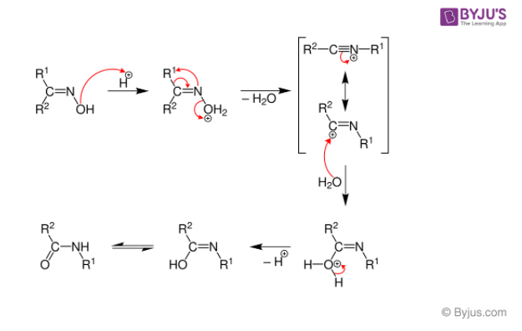
The process of Beckmann Rearrangement is as shown below-
- The oxime is shaped when cyclohexanone responds with the hydroxylamine.
- The Protonation of hydroxyl of oxime happens after the change of the alkyl substituent “trans” to the nitrogen
- At the same time, the N-O bond is severed with the expulsion of water.
- Later, tautomerisation process happens which protonates the molecule of nitrogen and then prompts the production of amine.

Applications
Some uses of this reaction are as below-
- It is used in the industries for the synthesis of paracetamol. This integration is achieved by the process of conversion of a ketone to a ketoxime with the help of hydroxylamine.
- It is mainly used in the synthesis of various steroids and drugs
- The Beckmann Rearrangement synthesis is helpful in the production of some chloro bicyclic lactams.

inacol Pinacolone rearrangement is a very important process in organic chemistry for the conversion of 1,2 diols into carbonyl compounds containing a carbon oxygen double bond. This is done via a 1,2-migration which takes place under acyl conditions.

Table of Contents
- Pinacol Pinacolone Rearrangement Process
- Pinacol Pinacolone Rearrangement Mechanism
- Uses of Pinacolone
- Frequently Asked Questions – FAQs

Pinacol Pinacolone Rearrangement Process
The pinacol pinacolone rearrangement process takes place via a 1,2-rearrangement as discussed earlier. This rearrangement involves the shift of two adjacent atoms. This reaction is a result of the work of the German chemist William Rudolph Fittig who first described it in the year 1860.

Pinacol and Pinacolone
Pinacol is a compound which has two hydroxyl groups, each attached to a vicinal carbon atom. It is a solid organic compound which is white.
The IUPAC name of Pinacolone is 3,3-dimethyl-2-butanone. Pinacolone is a very important ketone. It has a peppermint like or camphor like odour and appears to be a colourless liquid.

Pinacol Pinacolone Reaction
The pinacol pinacolone rearrangement proceeds through the formation of an intermediate which is positively charged. The methyl group in this intermediate proceeds to migrate from one carbon to another. This reaction can be given by
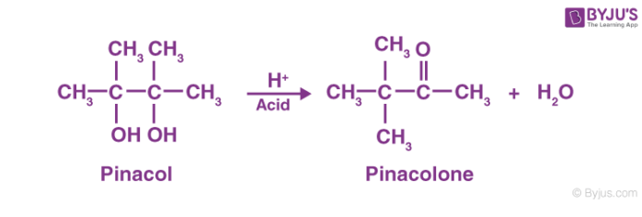

Pinacol Pinacolone Rearrangement Mechanism
The Pinacol Pinacolone rearrangement mechanism proceeds via four steps. Each of these steps is explained below.
Step 1: Since the reaction is carried out in an acidic medium, the hydroxide group of the pinacol is protonated by the acid.
Step 2: Water is now removed from the compound, leaving behind a carbocation. This carbocation is tertiary and therefore stable.
Step 3: The methyl group shifts to the positively charged carbon in a rearrangement of the compound.
Step 4: The oxygen atom which is doubly bonded to the carbon is now deprotonated, giving rise to the required pinacolone.
This reaction mechanism can be illustrated as:
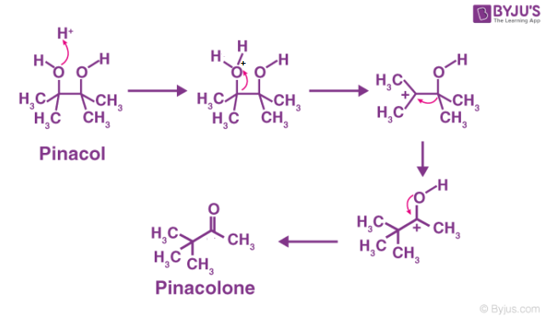
Thus, the required Pinacolone product is generated. It is important to note that this rearrangement is regioselective in nature. The rearrangement of the more stable carbocation yields the major product.

Uses of Pinacolone
The uses of the pinacolone product produced from the pinacol pinacolone rearrangement include:
- Pinacolone is used in Pesticides, Fungicides, and Herbicides.
- Pinacolone is used to prepare the cyanoguanidine drug – pinacidil.
- Another drug use of Pinacolone is its use in Stiripentol, which is used to treat epilepsy.
- Pinacolone is used to produce triadimefon which is used to control fungal diseases in agriculture.
The primary applications of pinacolone are in the drug industry.

